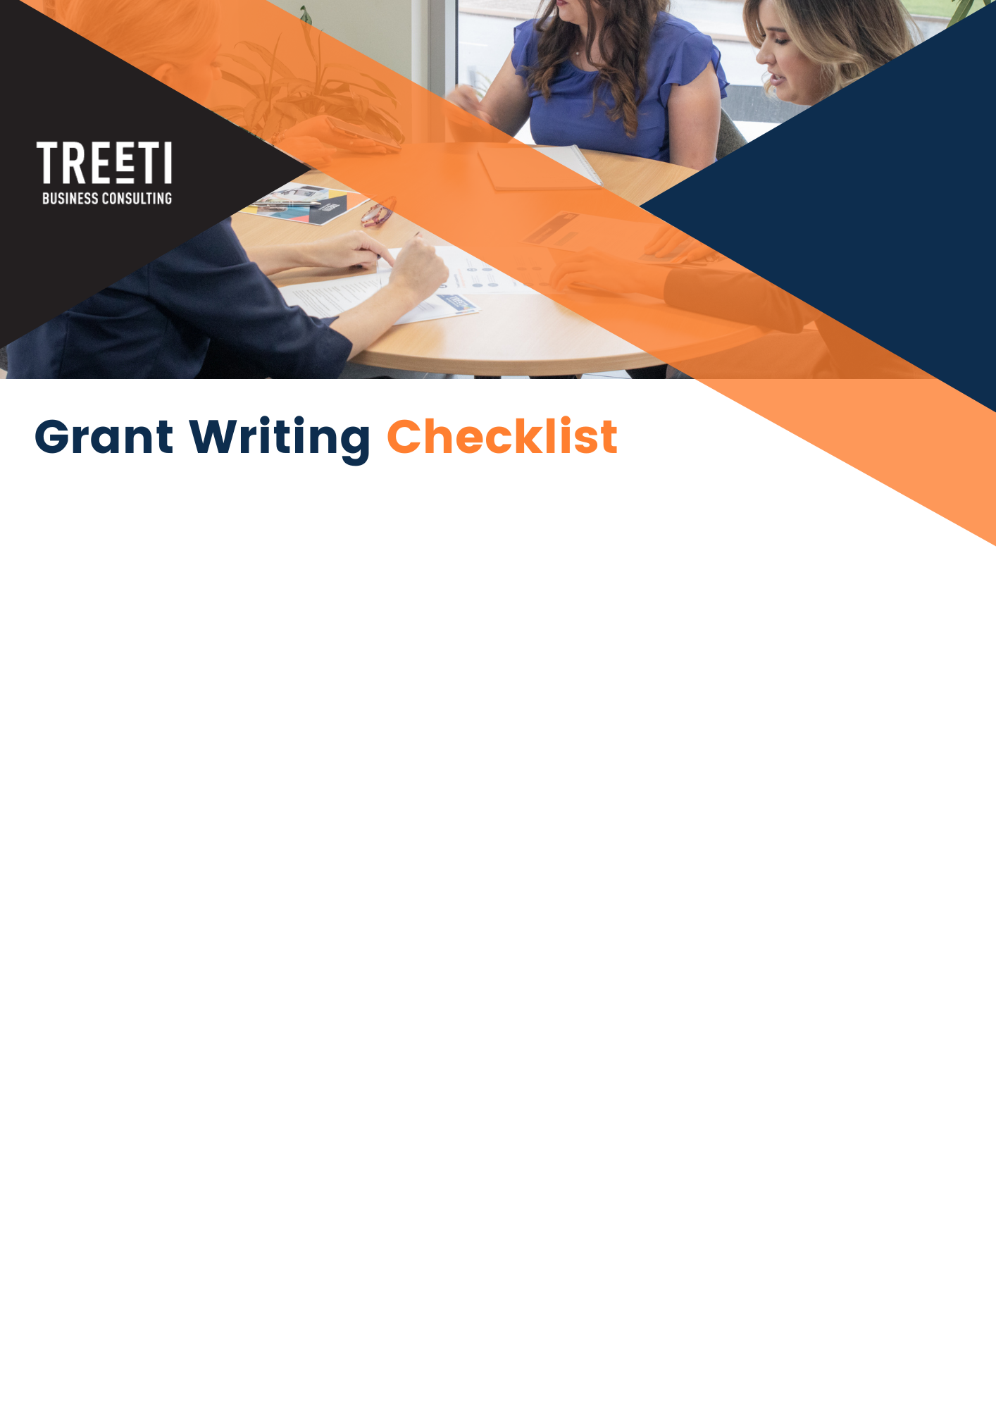

Requirement Checklist: | Yes
Below is a list of possible grant requirements. Only take note of those that are relevant in the grant application you are applying for. Not all grants ask for the list below:
Cover letter if applicable | ☐
Executive Summary - Overview of your business including vision and mission statements | ☐
Company Profile or Capability Statement | ☐
The purpose of the funding (uses) | ☐
The amount of funding required | ☐
Qualifications and Curriculum Vitae of key staff or sub-contractors | ☐
Project Plan | ☐
Complete Budget | ☐
All requested attachments | ☐
Testimonials or Referees (make sure to let all referees know that they have been named in a submission and may be contacted) | ☐
Reporting and Accountability Practices and Processes | ☐
Financial Management Systems and Processes | ☐
Conclusion or Summary | ☐

Grant Application | YES
Meets all eligibility criteria | ☐
Read and Understood all requirements | ☐
Application is in the correct format and meets technical requirements | ☐
All questions have been responded to thoroughly and clearly, addressing the specifics of every question | ☐
Language is simple and easy to read, with any acronyms also provided in full | ☐
Documents have been checked for accuracy and presentation | ☐
Application has been checked by a neutral party | ☐
All Attachments meet the requirements i.e. file type and size | ☐
All Attachments have been named and uploaded correctly | ☐
The Budget has been uploaded in the correct format (if a separate spreadsheet is required) | ☐
Project Plan is attached (if required) | ☐
Application will be submitted by the specified date and time | ☐
A copy of the application has been created and filed | ☐
Notes:

